1. Create a virtual machine with two operating systems, Windows 7 and Windows 10
(in this order). Choose Windows 7 as the default operating system, which will boot
after 5 seconds unless Windows 10 is manually selected.

2. Create a virtual machine with two operating systems, Windows 7 (or Windows 10)
and Ubuntu 16.04 (in this order) and configure the bootloader to:
a. Set Windows as default entry and boot after 15 seconds if the user does not
select another option in the menu.
b. Boot Ubuntu after displaying a 10 seconds countdown.
c. Boot Ubuntu without displaying the menu.
d. Boot Windows without displaying the menu.

3. If you lose the bootloader in exercise 2, use the tool “Boot-Repair”, which will let
you solve the issue. If necessary, use the following the instructions in the URL:
https://help.ubuntu.com/community/Boot-Repair
1.
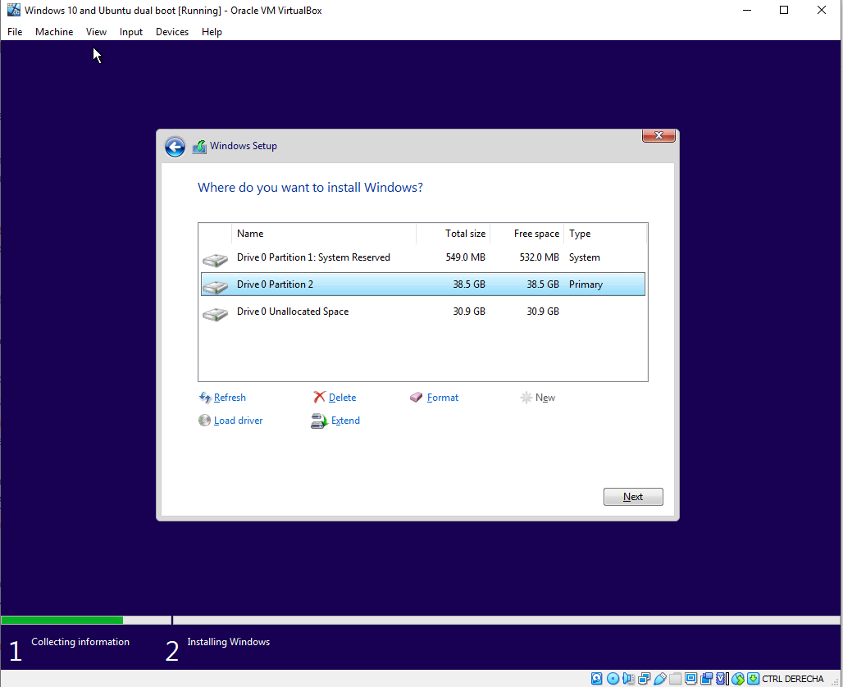

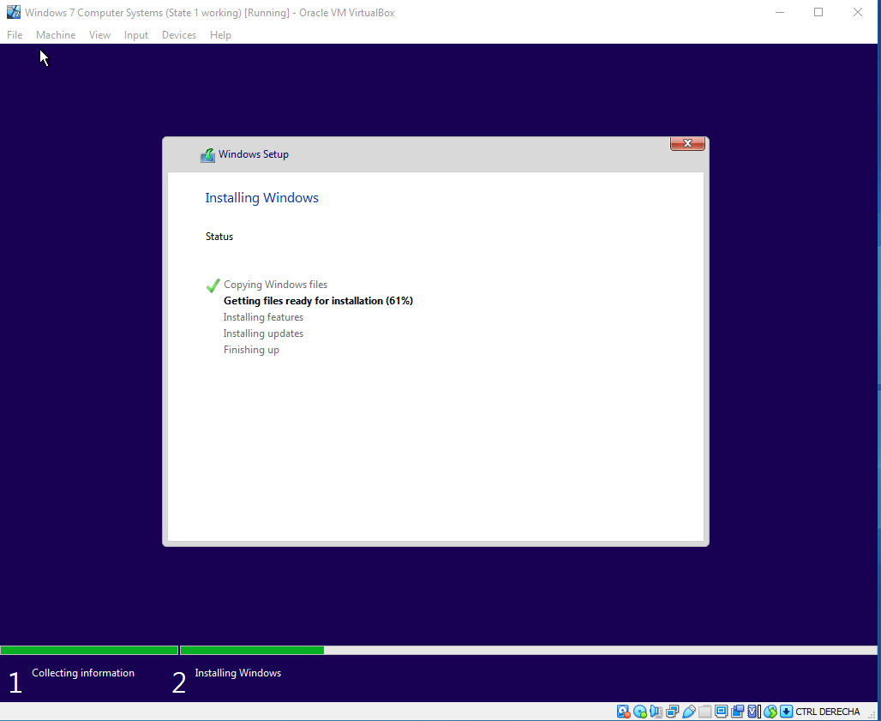

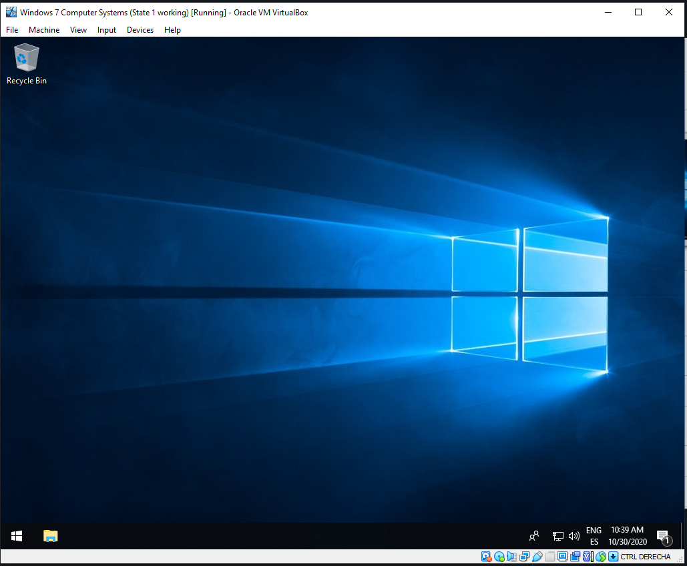

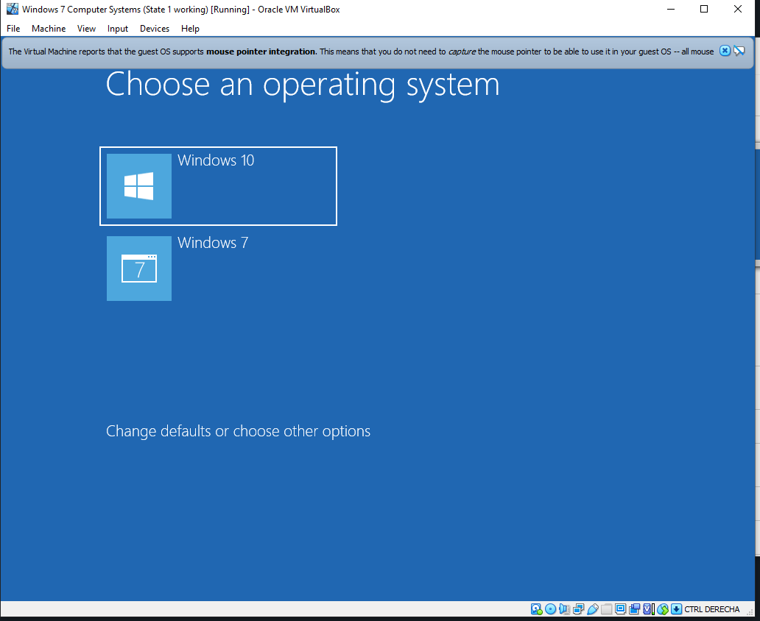
Since I cannot work with windows VMs at home, I will update the document with the part about setting the 5 seconds delay and Windows 7 as default OS.
2.

Here I’m making the hard drive partitions thought the Windows 10 setup, because first we are going to install the Windows OS. In this case we leave 40GB for Windows and 30 for Ubuntu.

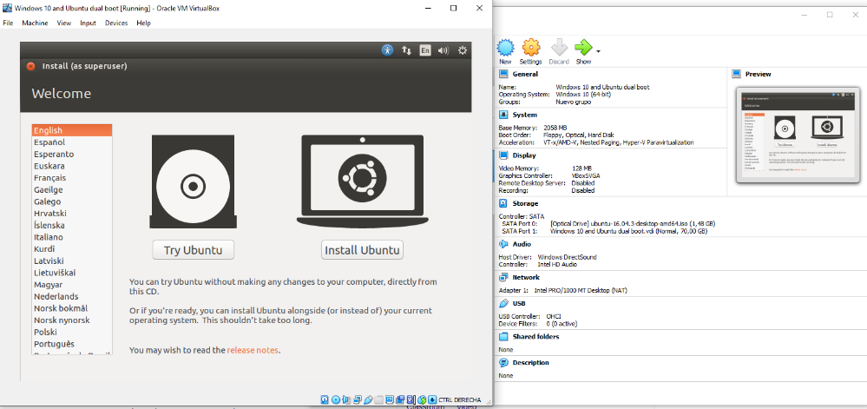
After the installation of Windows 10 I select the Ubuntu .iso as boot to start the setup.

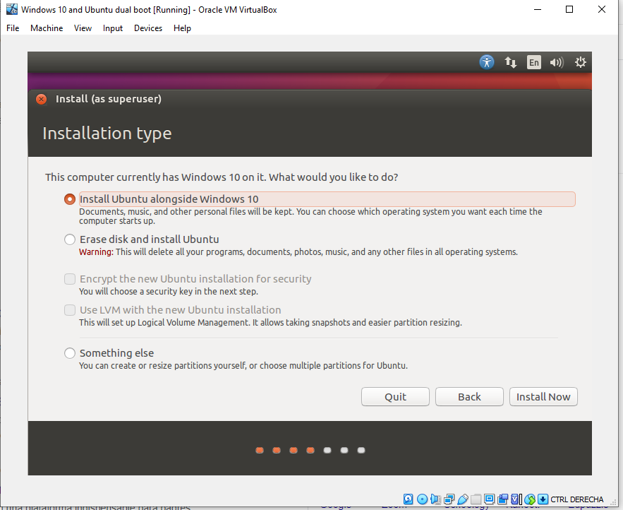
Here we have two options, we can leave Ubuntu create the partitions or we can make them. For the simplicity I’m going to led Ubuntu make them, but for the assignment I’ll do it manually.

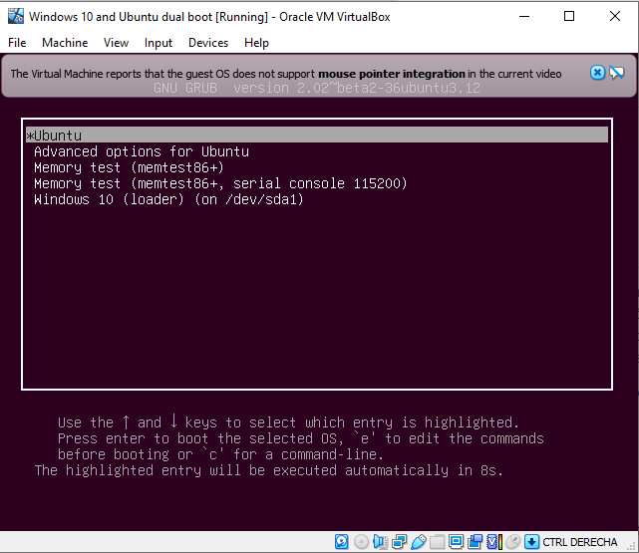

After the Ubuntu installation each time we start the VM it will prompt the bootloader options where we can choose what OS boot.
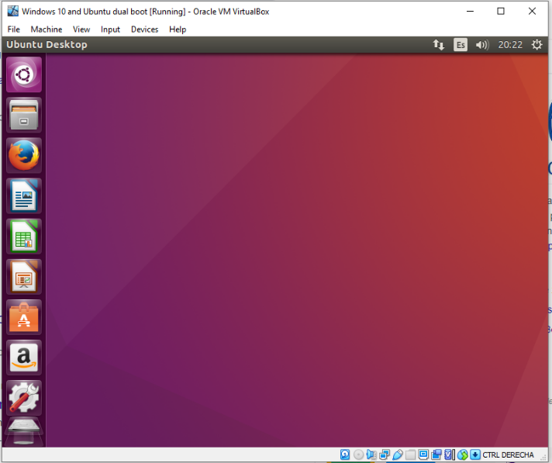

a.
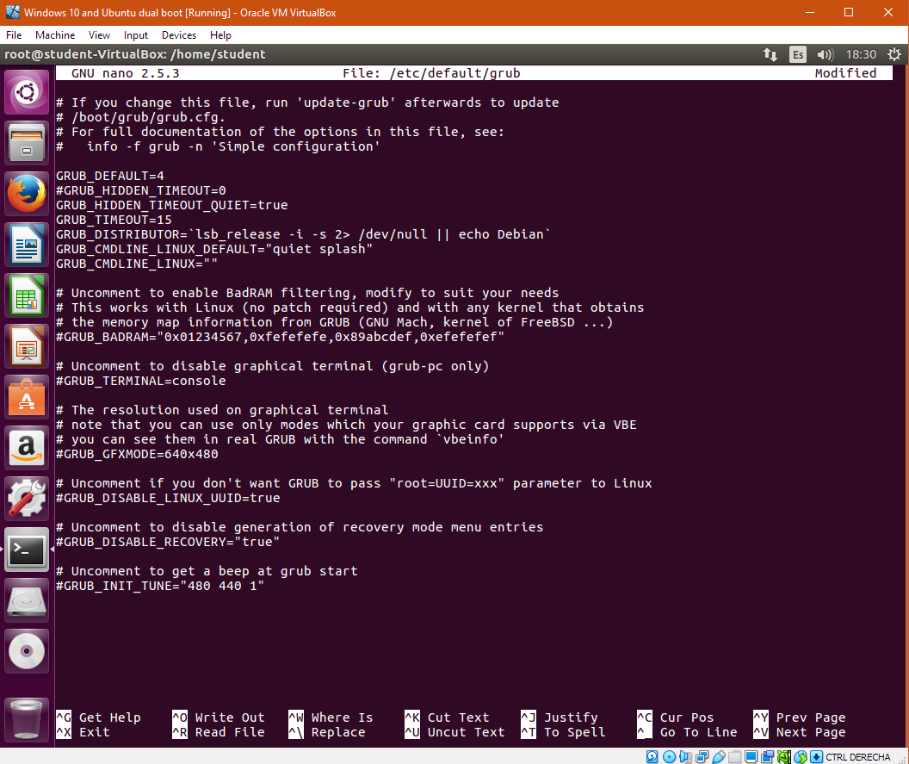
In exercise 2a we have to change the value of GRUB_TIMEOUT with nano, to be able to modify the countdown while we can choose the OS, if not OS is selected the system will execute automatically with the default one defined in the GRUB_DEFAULT line.
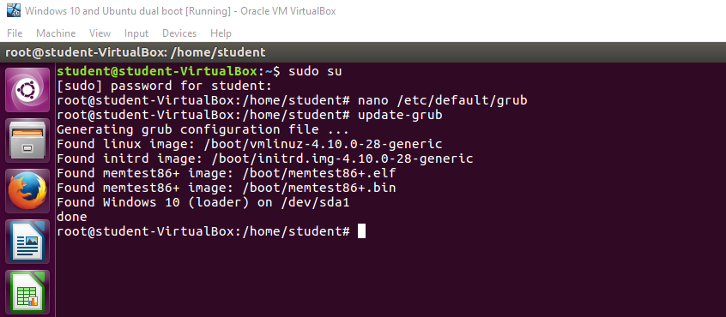
As always a grub-update It’s required to update all the changes before the reboot.
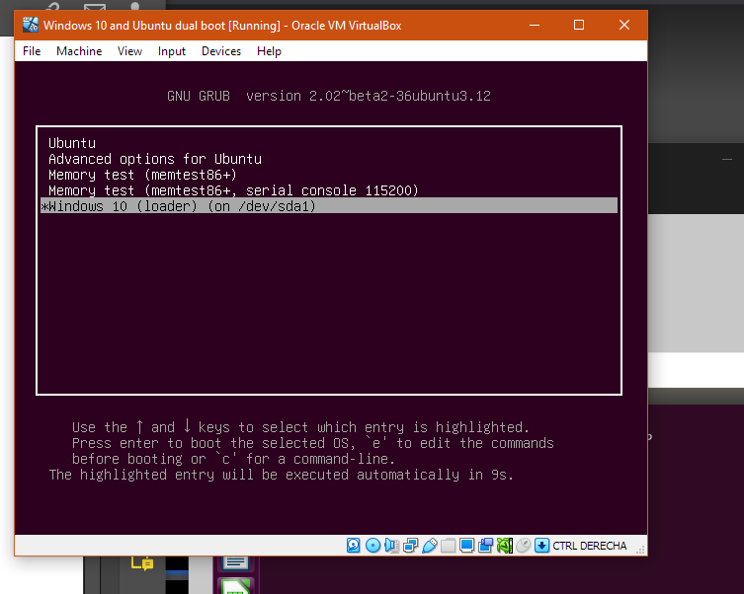
As we can see, a countdown is displayed down and Windows 10 is selected as default entry.

b.
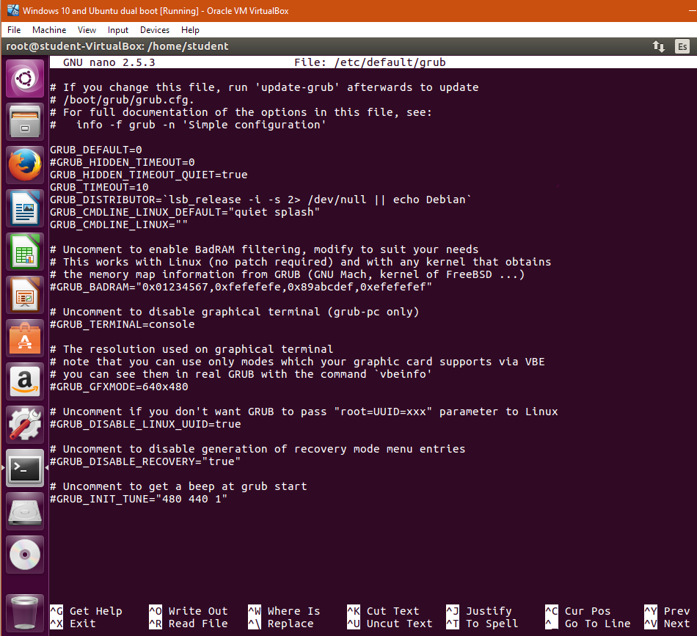
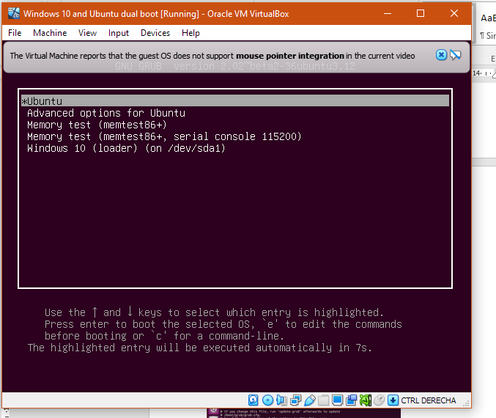
c.

Method 1
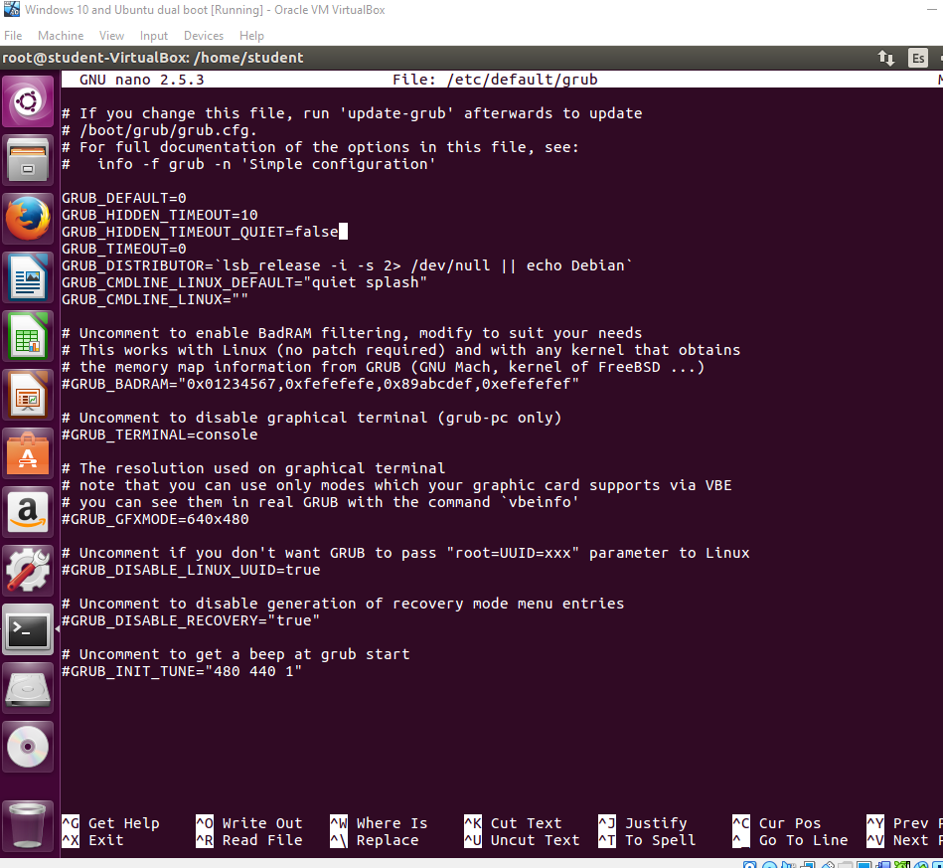

As always a grub-update It’s required to update all the changes before the reboot.

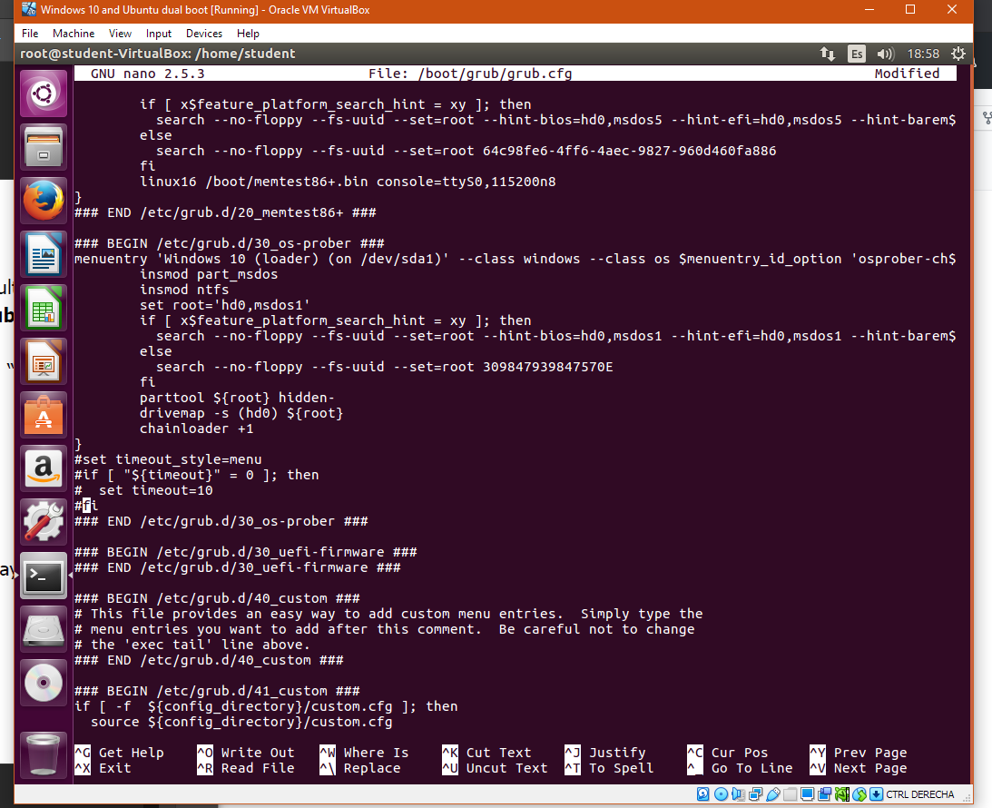

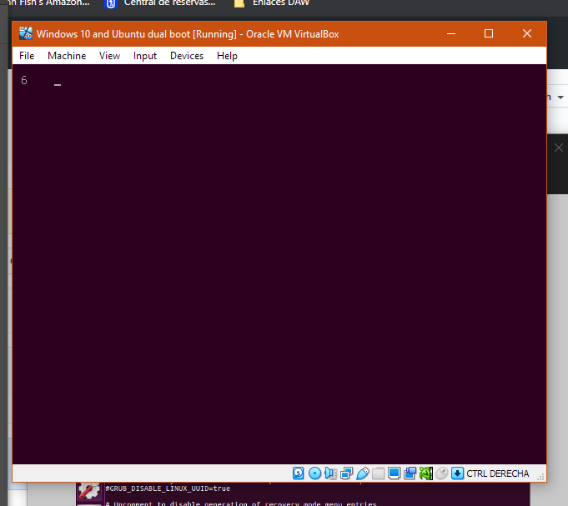
Displaying a 10 seconds timeout without showing the menu.
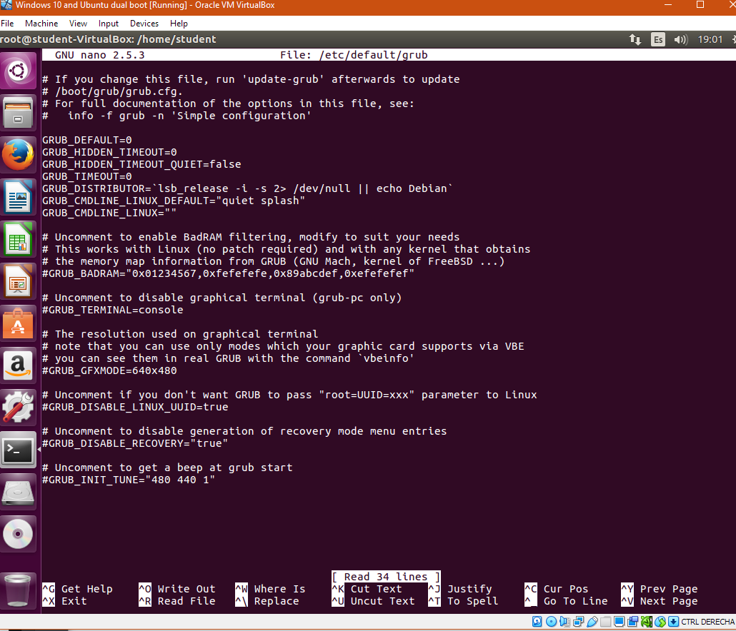

As always a grub-update It’s required to update all the changes before the reboot.

To hide the menu we also need to make some changes on the .cfg file where the bootloader parameters are saved. In the set timeout_style=menu line we have a sentence where it will force to show the bootloader menu, if we comment this lines with # they won’t be doing nothing, so we’ll be able to hide the menu.
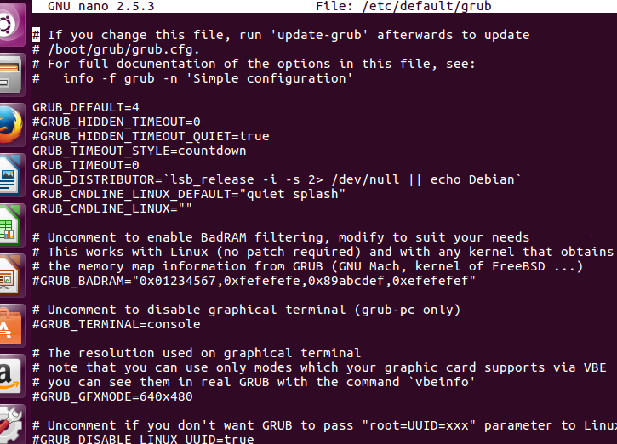

As always a grub-update It’s required to update all the changes before the reboot.

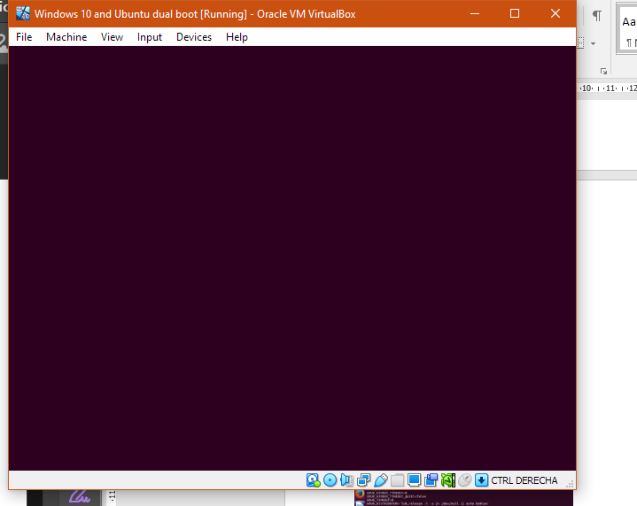

Boot Ubuntu without displaying the menu.

Method 2 – In method 2 we are going to use GRUB_TIMEOUT_STYLE to define it as countdown, the value of countdown is determined in the GRUB_TIMEOUT line, that sets the amount of time the entry menu is showed.
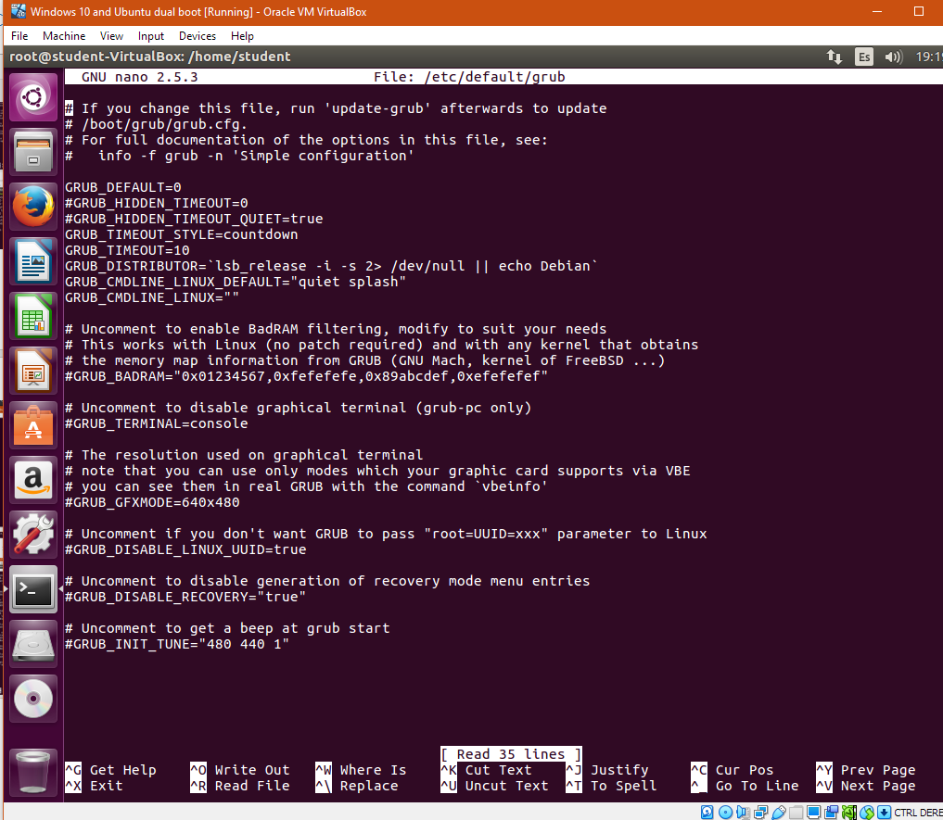

To hide the menu we also need to make some changes on the .cfg file where the bootloader parameters are saved. In the set timeout_style=menu line we have a sentence where it will force to show the bootloader menu, if we comment this lines with # they won’t be doing nothing, so we’ll be able to hide the menu.

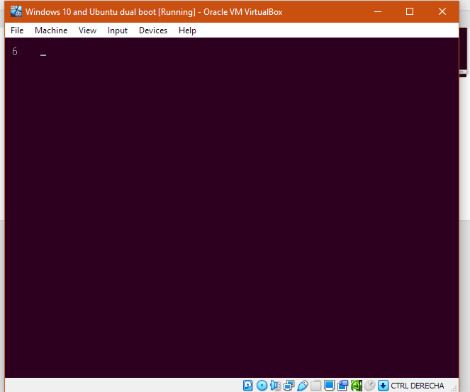
Displaying a 10 seconds timeout without showing the menu.

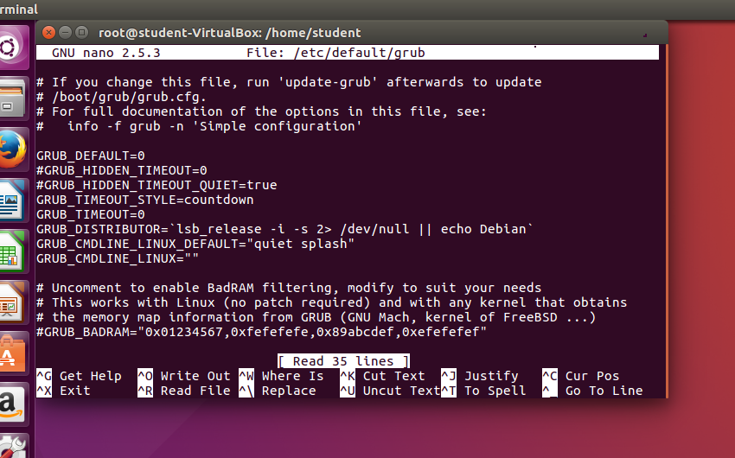
In method 2 we are using the GRUB_TIMEOUT_STYLE=countdown to set the countdown as the variable defined in GRUB_TIMEOUT=0, that indicates the amount of time the bootloader menu is showed before it automatically executes in the default OS defined in the GRUB_DEFAULT line, in this case Ubuntu.

As always a grub-update It’s required to update all the changes before the reboot.

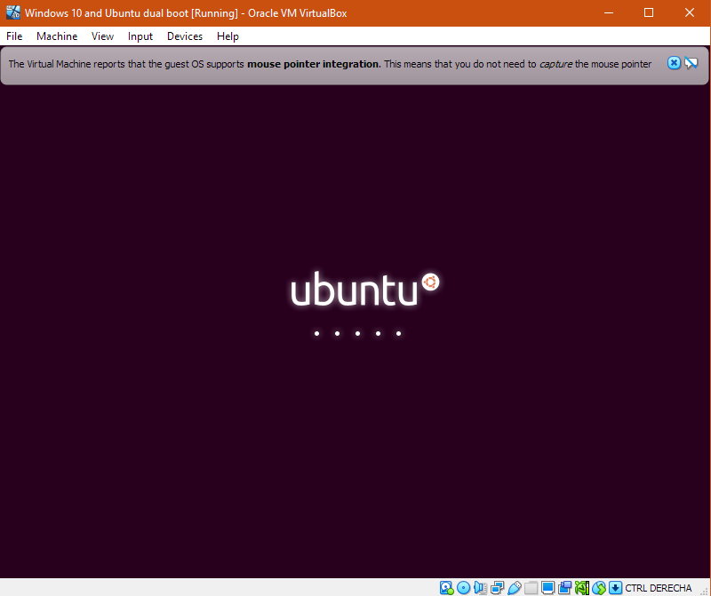
Boot directly into Ubuntu

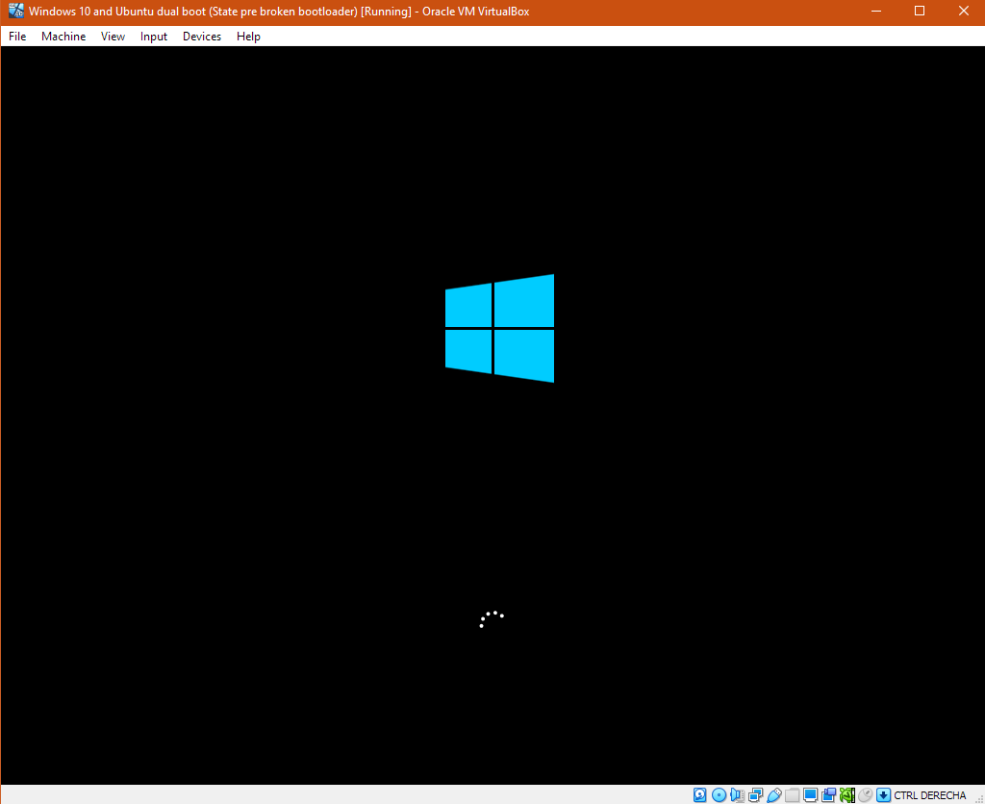
Now it boots directly into Windows 10, because we’ve changed GRUB_DEFAULT=4.

